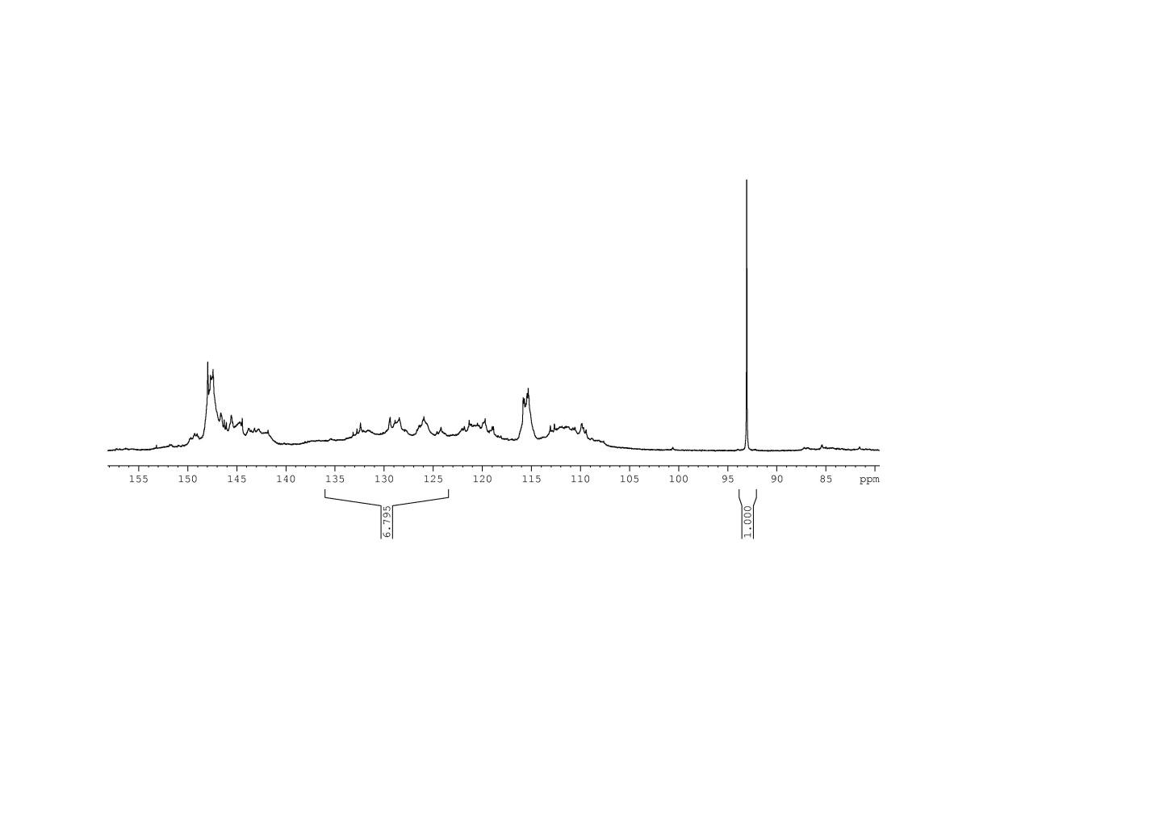
(A)

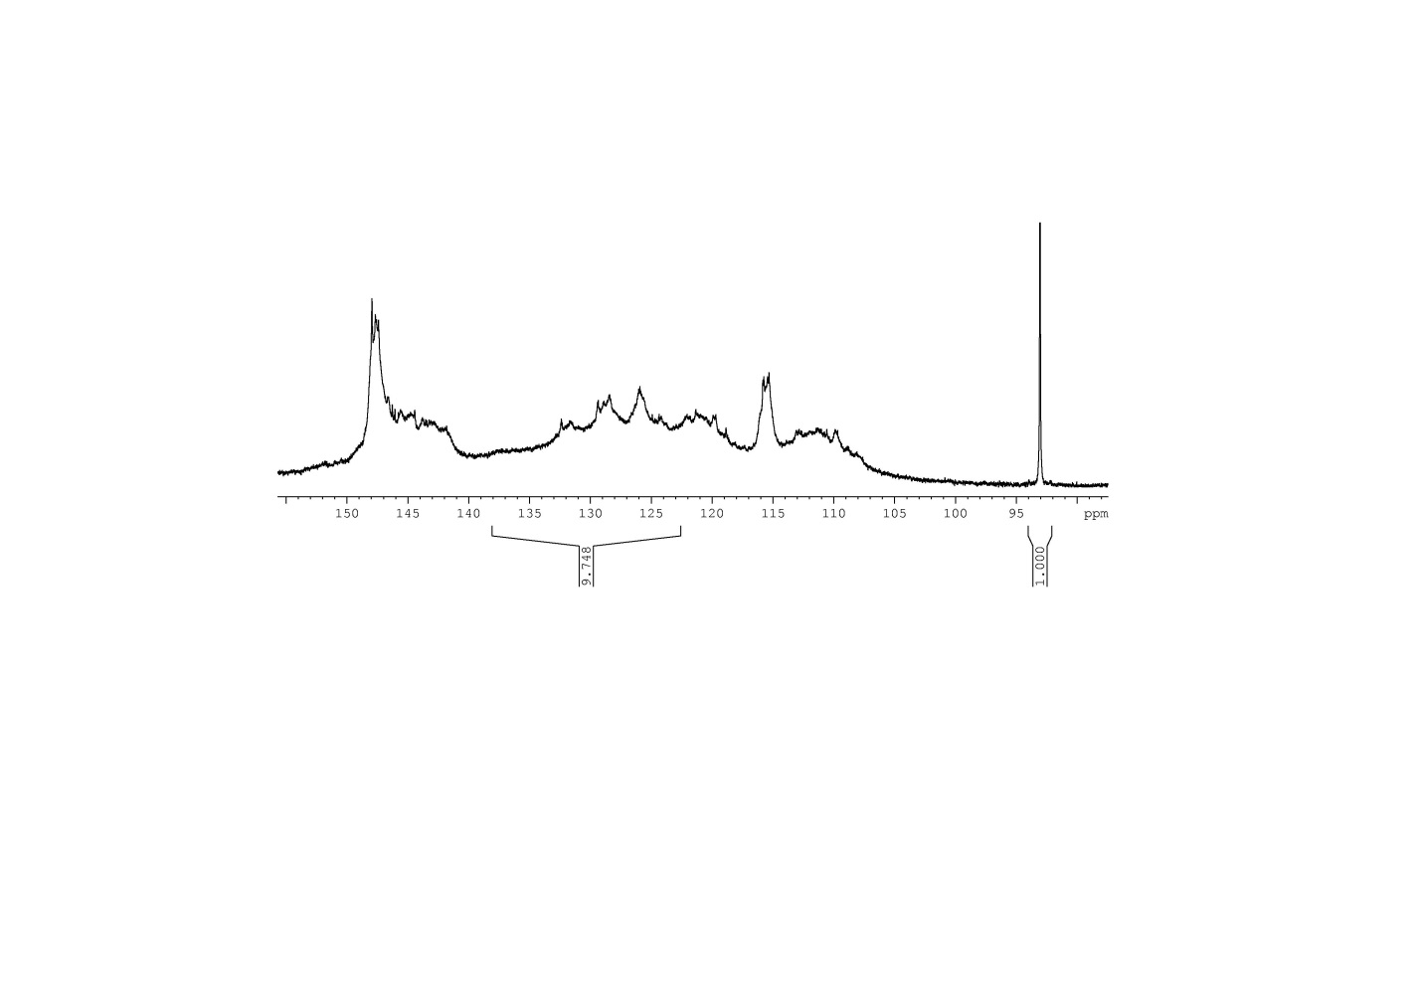
(B)

Figure S1

Amount of Carbon Between 123 and 138 ppm
Amount of Unsaturated Carbon Between
123 to 138 ppm
Starting ASKL | 3.50 mmol/g
ASKL after  Control reaction | 5.00 mmol/g

Figure Caption
Figure S1. (A) 13C NMR of the starting ASKL sample. (B) 13C NMR of the ASKL after control reaction (heating at 160 °C for 2h). The amount of carbon increases dramatically between 123 to 138 ppm.

